英语转换器在线翻译

英语转换器在线翻译
这个不叫转换器，一般叫电子词典或词霸。
国产的金山词霸是老牌的了，很不错，另外还有一款灵格斯词霸(又名：灵格斯翻译家)也很不错，我自己用的就是这款，下载后，可以自动进行全文翻译，正确率不错，不过也是在线翻译的，像谷歌、百度等知名搜索引擎都是有免费在线翻译服务的，如果追求完美正确，也可以使用收费的人工翻译。
下面使用灵格斯翻译的你这些句子： 1 Account 2 to adapt to new life 3 located in the city center 4 On the map to find the location of stores 5 Muddy black and white 6 Confused on the new ideas 7 make a decision 8 5 days continuous leave 9 Live alone 10 Ever since he entered college, he has learned to live alone. 11 This morning we have a row on the four English lessons. 12 Every Sunday he up late. 13 He was Vice-Chancellor's speech at the meeting puzzled. 14 They must quickly adapt to campus life.

在线中文翻译英文转换器
操作步骤： 1：首先我们在手机应用市场打开我们的翻译工具“语音翻译器”，打开后会有引导标志指引大家接下来的操作。选择手机翻译工具的好处，在于使用时方便快捷，并且不容易忘记携带。 2：打开翻译工具，在语音翻译和文本翻译两种翻译模式中选择一种自己喜爱的翻译模式，进行语句翻译时选择文本翻译模式。 3：选择语种，在源语种和目标语种的选择上，源语种我们有中文和中文繁体两种选择，目标语种我们选择英语。 4：点击文本框输入中文汉字，输入完成后，点击翻译按钮。 5：翻译结果页面，翻译结果会在语音播放的同时出现一个带有文字的文本框，而文本框中有个语音播放按钮，点击可以重复播放这段英语翻译。 所以这段话的翻译为：Pay attention to hygiene, frequently drying bedding, maintain room ventilation, cold and warm, do not go to crowded places, such as Internet cafes, cinemas, public environment such as classrooms, dormitories twice a day for disinfection

用什么软件可以将中文转换成英文
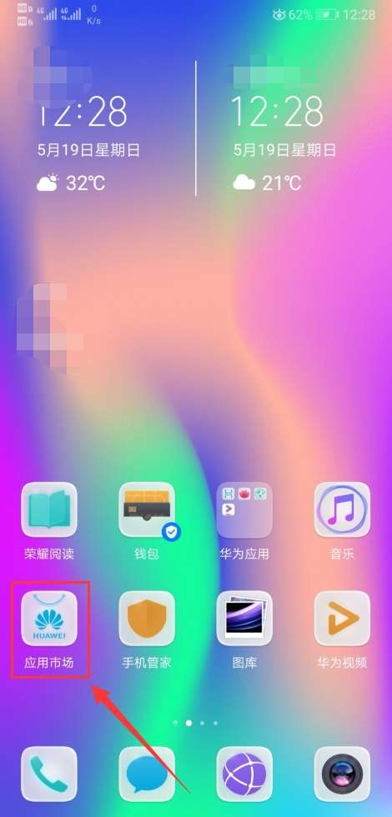
网易有道词典软件可以将中文转换成英文。 手机上下载网易有道词典的具体操作步骤如下： 1、在此以华为荣耀10为例，首先在手机上点击打开应用市场。 2、接着在此软件的页面上方的搜索栏内输入“网易有道词典”，然后点击搜索出来的选项中的后方的“安装”选项。 3、等待系统下载完成然后自动安装之后，就可以点击进入此软件的页面中了。

中英文在线翻译
Work experience:
I graduated from high school until now has been engaged in the clothing industry. I graduated from high school in a small store as an apprentice year,
Kumite board and make clothing after my understanding on the clothing r&d center (dalian) professional education institute of clothing, 1
In every link of the relevant industrial clothing. After graduation I in dalian as an individual southwest road play board factory and a pattern cutter. After one year work, feel the need to improve my ability. So I went in 2003 study enrollment identity liaoning art vocational college majoring in fashion design and further study the fabric and garment industrial processes. In school, I successively during a competitive person and bear the student cadre. By the dean and leadership. After my graduation design in guangzhou as assistant 1 year. Due to the home appear serious accidents in September 2006 to return in dalian. A year later I in lily resort to supermarket shopping) (former fwu dry garment production and individual engaged mainly in modified until now. Because of this store resettlement so I decided to find a steady job
I also use in learning English during the individual leisure and in April in the ielts. Got five points (than domestic English four levels of some high) last year I was in ef foreign language school strengthened 4 months speaking and listening (teachers) although oral English is very fluent exchange but no problem at all. Reading, writing is our Chinese strengths.
Although I haven't done my orders, but in the two schools are involved in this field. I know the basic process. Another one of my best friends are engaged in the documentary work six or seven years. I told them about the process and some documentary. I feel in my experience can quickly into the industry.
More than two year I just struggle good time, 28, hoping to find a job in the long-term stability and can realize their life values of your company to create as many benefits

在Word文档里怎样转换中英文
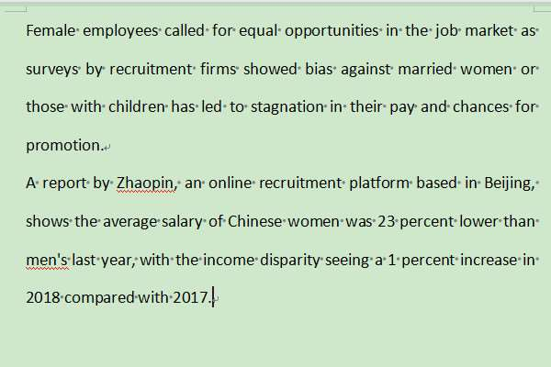
准备工具/材料：装有windows 10的电脑一台，word软件。 在Word文档里转换中英文的方法如下： 1、打开一个有英文段落的wrod文档。 2、使用快捷键“ctrl-A”选择所有英文段落，单击WPS上方的列“审阅”，选择其所属的列“翻译”，然后选择第一列“翻译”。然后右边会出现一个“翻译”显示框，英语会自动翻译成中文。 3、点击文档空白处，选择“插入”，翻译后的中文可以直接输入到word文档中，或者显示框中的中文可以直接复制粘贴到任何文档中。这样，可以快速翻译更多的文档内容，但准确性一般，因此有必要再次检查和修改它们。 4、为了提高翻译的准确性，建议在“翻译”显示框的下栏选择“完全翻译”，自动跳转到默认浏览器打开网页，直接点击“文档翻译”，自动将英文翻译成中文。与原文的翻译相比，网页中的翻译显然相对流畅自然，符合汉语的用法。 5、如果需要获得更高的翻译精度，可以在“翻译”显示框的下栏中选择“手动翻译”，自动跳转到默认浏览器打开网页，然后单击“立即订购”选择手动翻译。

中英文在线翻译器
Mother was so tired that she fell asleep as soon as she lay down in bed. 遇到这样的英文翻译成中文很简单，你可以和我一样在手机里安装一个语音翻译器，支持中英文语音翻译和文本翻译两种翻译模式，并且支持互译，翻译速度快，翻译准确率高。 操作步骤： 1：打开手机翻译工具 语音翻译器 后，首先我们选择翻译模式，总共有语音翻译和文本翻译两种翻译模式， 我选择语音翻译模式。 2：选择源语种和目标语种，源语种选择中文，目标语种选择英文。 3：进入在线翻译英语页面，点击最下角的中文标志按钮，进入录音页面开始说话，录音完成后点击完成按钮，开始进入翻译页面。 4：翻译结果页面，翻译结果会以中英文翻译文字和英语语音播放两种形式同时出现，而在文本框中有一个喇叭按钮，点击可以进行重复的语音播放。 5：文本翻译模式，在文本翻译模式下，将中文输入或者粘贴在文本框中，点击翻译按钮，即可得到翻译结果。

